>DB2CMD

It will open new command console

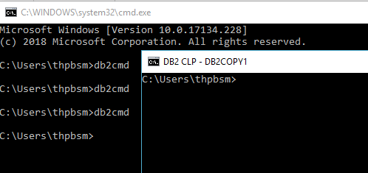

>DB2fs

It will open new window

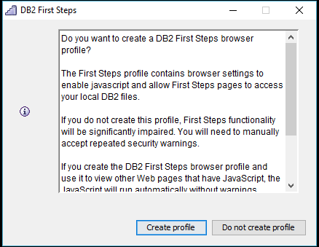

Click on - create profile

It will open new window

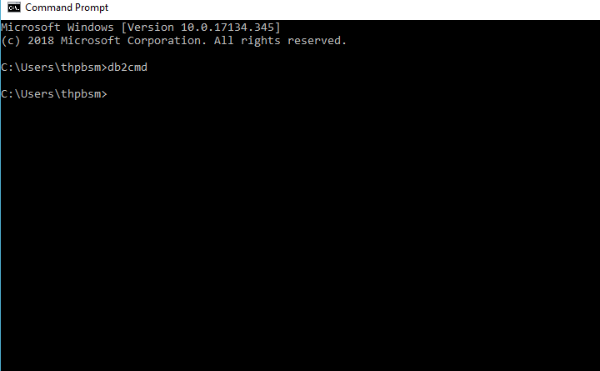

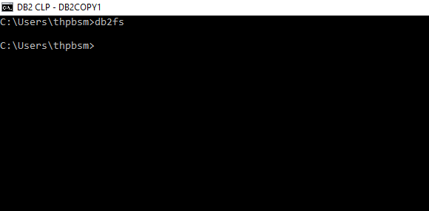

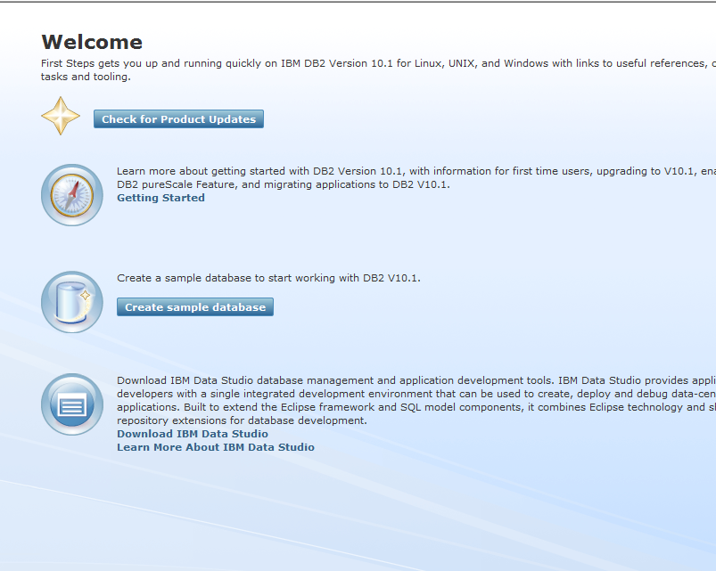

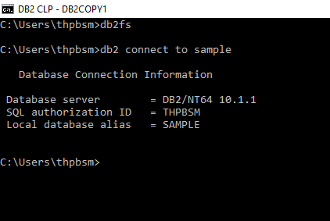

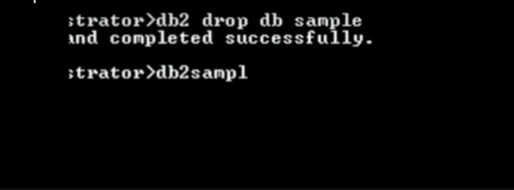

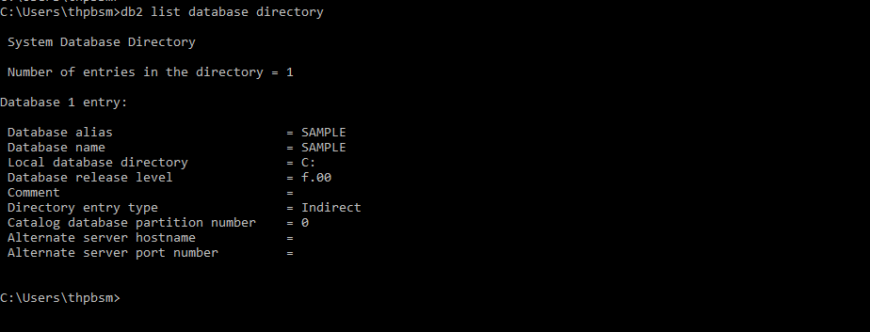

GO CREATE TABLE AUDITLOG(TRAN_ID VARCHAR(50),SERVICE_NAME VARCHAR(50),REQ_DATE DATE,RES_DATE DATE,ELAPSED_TIME TIME,CHANNEL VARCHAR(10),STATUS VARCHAR(20),ID_NUMBER VARCHAR(10))

db2 INSERT INTO AUDITLOG(TRAN_ID,SERVICE_NAME,REQ_DATE,RES_DATE) VALUES('12345','GDT','10-21-2018','10-21-2018')

2018-10-21-14.12.23.809000

db2 CREATE TABLE AUDITLOG(TRAN_ID VARCHAR(50),SERVICE_NAME VARCHAR(50),REQ_DATE TIMESTAMP,RES_DATE TIMESTAMP);

db2 INSERT INTO AUDITLOG(TRAN_ID,SERVICE_NAME,REQ_DATE,RES_DATE) VALUES('12345','GDT','2018-10-21-09.56.20.456','2018-10-21-09.56.20.788')

db2 DISCONNECT ALL

db2 CONNECT TO SAMPLE